HalloIT.java

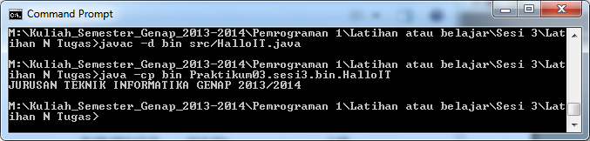

Biodata.java

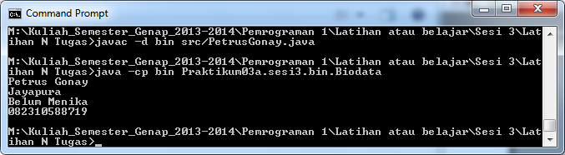

BiodataKu.java

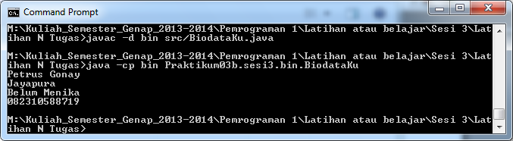

PetrusGonay.java

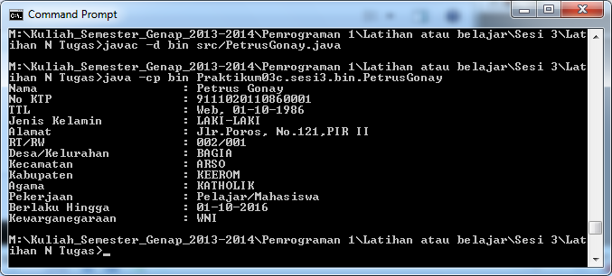

DemoVariabel.java

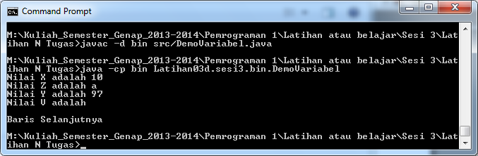

DemoVariabel1.java

